Thermal Processing (THM)
ASAAT Exercise 4: feature model and analysis architecture model for the cake factory. This is the work package of Elena (prefix THM). It covers use cases UC5 & UC6, UC9 and UC10 and failure cases FC8 to FC18. Signal names follow the agreed signal list of the alignment baseline. Block IDs are THM-AF-nn for the function blocks (01 to 09) and THM-FD-nn for the device blocks (01 to 13).

Scope Note

Stakeholders
• Production Overseer: gets the warnings and errors (UC2)
• Maintenance Department: repairs the depositing equipment, the baking zones, the temperature measurement and the cooling. The Health Monitor notifies them.
• Health Monitor: finds faults from the machine status and the error events
• Batter Preparation: sends the batter and has to hold new batches while depositing is stopped
• Finishing & Packaging: receives the cooled cakes, supplies clean pans and can ask us to stop new pans
• Production operators: empty the refuse container

Needs, Goals, and Objectives
• Need: the batter from Batter Preparation has to become correctly filled, correctly baked and properly cooled cakes that go on to depanning.
• Goal: only correctly filled pans get baked, only cakes at 97 °C ± 0.5 °C leave the tunnel and only cakes at a safe temperature leave cooling. The line should keep running when a device fails, because availability is our main quality attribute.
• Objectives: check every pan and every cake (100 %). Recover automatically where we can (FC8, FC9, FC12, FC14, FC16, FC17). Where we cannot, call Maintenance and stop only the new pans (FC10, FC11, FC13, FC15, FC18). Throw away as little product as possible, so cakes go to the cooling buffer instead of the bin.

Drivers and Constraints
• A filled pan must be within the legal EU weight standard for the average quantity, and the scale must be calibrated (UC5 & UC6).
• Each cake must be 97 °C ± 0.5 °C inside when it leaves the tunnel (UC9).
• Cakes may only be packaged at room temperature. If more than 30 minutes pass between a cooling failure and its repair, the cakes are discarded (UC10).
• The baking tunnel cannot go backwards. If it has a problem, no new pans are let in, and the pans already inside finish and are checked at the exit (failure-case rule).
• Repeated failures: one bad product is removed. If the same check fails several times in a row, Maintenance is called (failure-case rule).
• The cooling buffer is on a separate level, so cakes are kept instead of thrown away. Cakes that waited too long are thrown away (failure-case rule).
• Baking Zone Control must not stop while product is inside. The sprays can fail independently of the band motion (Table II).
• The services run in Docker containers, the band sections can be driven independently and the components report through the message bus.
• Of the 11 failure cases in this slice, the system resolves FC8, FC9, FC12, FC14, FC16 and FC17. FC10, FC11, FC13, FC15 and FC18 need Maintenance.

Scenarios
Nominal: the batter arrives and a pan is at the depositing point. The fixed amount of batter is deposited and the filled pan has the right weight. It is baked with all zones in range and the cake leaves the tunnel at 97 °C ± 0.5 °C. It is cooled to the safe temperature and handed to depanning with its batch ID.
Off-nominal:
• no pan at depositing (FC8)
• wrong fill weight (FC9), and several times in a row (FC10)
• baking zone temperature wrong (FC11)
• cake under- or overcooked at the tunnel exit (FC12)
• temperature measurement at the tunnel exit broken (FC13)
• cake still too hot after cooling (FC14)
• cooling stops working (FC15) and is fixed again (FC16)
• cake waited too long in the cooling buffer (FC17)
• cooling buffer full (FC18)
• Finishing & Packaging asks us to stop new pans after a washing or wrapping fault (FC23, FC25)
• the monitoring system announces a band halt, slow-down or restart (UC2, FC19, FC20)

External Interfaces
Signal name | Direction | Counterpart | THM block | Carries | Source
Batter ready | In | BAT | THM-AF-01 | Finished batter, batch ID | UC4 (UC5 & UC6)
Depositing stopped / working again | Out | BAT | THM-AF-01 | Stopped or working-again state | FC7
Pan request | Out | FIN | THM-AF-01 | "Waiting for pan" request when no pan is at depositing | FC8
Pan for washing | Out | FIN | THM-AF-01 | Diverted pans after a wrong fill weight (emptied), batch ID | UC5 & UC6, FC9
Clean pan supply | In | FIN | THM-AF-01 | Clean pan with current stock level | UC12, FC23
Stop / resume pan admission | In | FIN | THM-AF-01 | Stop when packaging or washing faults, resume after repair | FC23, FC25
Cooled cake | Out | FIN | THM-AF-03 | Cake in its pan, batch ID, only at or below T_safe | UC10, UC11
Log, warning, error and discard events | Out | MON | THM-AF-06 | Reason, time, batch ID, severity (log, warning, error, discard) | UC2, FC12, FC17
Machine status (heartbeat) | Out | MON | THM-AF-07 | Heartbeat / health state of controllers and devices | FC13, FC22, FC28
Band state change | In | MON | THM-AF-08 | Halt, slow-down or restart of the band | UC2, FC19, FC20
Repair confirmed | In | MON | THM-AF-09 | Machine id, repaired | FC10, FC11, FC13, FC15, FC16, FC18

The direction is seen from THM. THM = Thermal Processing, FIN = Finishing & Packaging, BAT = Batter Preparation, MON = Line Monitoring & Health and Band Transport. "Repair confirmed" was added to the signal list for all slices. MON still has to confirm it.

Open parameters
Symbol | Meaning | Value / source
N_wrong | Number of out-of-tolerance fills in a row that triggers the lockout (FC10) | to be set with Maintenance
T_adjust | Time a zone may stay out of range after adjustment before it is flagged faulty (FC11) | to be set
T_resp | Maximum silence of the temperature measurement at tunnel exit before it counts as broken (FC13) | to be set
T_hb | Heartbeat interval of each controller (FC28) | proposed 5 s; agree with MON
T_safe | Safe core temperature for depanning = room temperature (UC10) | to be set; shared with FIN-REQ-02
T_wait | Maximum waiting time of a cake in the cooling buffer (FC17) | default 30 min (UC10)
S_low | Low clean-pan stock level at which fewer pans are filled (FC23) | to be set with FIN
Fill tolerance | Legal tolerance of the target fill weight (UC5 & UC6) | EU average-quantity rules; recipe target
Zone range | Allowed temperature band of each baking zone | from the recipe
NFR values | Availability 99.5 %, detection 15 s, recovery 60 s, accuracy 0.1 {deg}C, reaction 1 s, event 5 s (THM-REQ-71 to 78) | Our proposal; the sources do not give values

Requirements

Functional requirements
Req ID | Requirement | Rationale | Source (UC/FC) | Feature ID | Block ID(s)
THM-REQ-01 | The system shall accept finished batter together with its batch ID from Batter Preparation through the signal "Batter ready". | Entry point of the slice; the batch ID is needed to trace every cake back to its batter. | UC5 & UC6 | THM-FEAT-01 | THM-AF-01
THM-REQ-02 | The system shall detect whether a pan is present at the depositing point before it releases any batter. | Batter must never be released onto an empty conveyor spot. | UC5 & UC6 | THM-FEAT-02 | THM-AF-01, THM-FD-01
THM-REQ-03 | When a pan is present at the depositing point, the system shall deposit the recipe-defined fixed amount of batter into that pan. | Core function of depositing; the fill amount comes from the recipe. | UC5 & UC6 | THM-FEAT-01 | THM-AF-01, THM-FD-02
THM-REQ-04 | While no pan is present at the depositing point, the system shall withhold batter. | Prevents batter from being spilled on the band. | FC8 | THM-FEAT-02 | THM-AF-01, THM-FD-01, THM-FD-02
THM-REQ-05 | When no pan is present at the depositing point, the system shall send the signal "Pan request" to Finishing & Packaging. | Tells the pan supply that depositing is waiting; handled by the system without Maintenance. | FC8 | THM-FEAT-02 | THM-AF-01
THM-REQ-06 | When a pan is detected after a pan request, the system shall resume depositing. | Depositing recovers on its own as soon as the pan arrives. | FC8 | THM-FEAT-02 | THM-AF-01, THM-FD-01
THM-REQ-07 | The system shall weigh every filled pan. | Every pan is checked (100%), not a sample. | UC5 & UC6 | THM-FEAT-03 | THM-AF-01, THM-FD-03
THM-REQ-08 | The system shall let a filled pan continue toward baking only if its weight is within the legal tolerance (EU rules for the average quantity) of the target fill weight. | Business rule of UC5 & UC6: the weight must be within the legal standard. | UC5 & UC6 | THM-FEAT-03 | THM-AF-01, THM-FD-03, THM-FD-04
THM-REQ-09 | The system shall not start depositing while the fill-weight measurement is not calibrated. | Special requirement of UC5 & UC6: the scale must be calibrated. | UC5 & UC6 | THM-FEAT-03 | THM-AF-01, THM-FD-03
THM-REQ-10 | The system shall divert every filled pan whose weight is outside the tolerance off the band. | Wrong fills must not be baked. | UC5 & UC6, FC9 | THM-FEAT-03 | THM-AF-01, THM-FD-03, THM-FD-04
THM-REQ-11 | The system shall discard the batter of every diverted pan. | The pan can only be reused if it is emptied. | FC9 | THM-FEAT-03 | THM-AF-01, THM-FD-04
THM-REQ-12 | The system shall send every diverted pan to Finishing & Packaging for washing through the signal "Pan for washing". | The pan is recycled, not lost (UC5 & UC6 postcondition). | UC5 & UC6, FC9 | THM-FEAT-03 | THM-AF-01
THM-REQ-13 | The system shall publish a log event (reason, time, batch ID) for every wait for a pan and for every diverted pan. | UC5 & UC6 logs these events onto the message bus; needed for traceability. | UC5 & UC6, FC8, FC9 | THM-FEAT-27 | THM-AF-01, THM-AF-06
THM-REQ-14 | The system shall accept clean pans together with the current clean-pan stock level through the signal "Clean pan supply". | Closes the pan loop with Finishing & Packaging. | UC12, FC8 | THM-FEAT-01 | THM-AF-01
THM-REQ-15 | When the received clean-pan stock level is below the low-stock limit S_low, the system shall fill fewer pans. | FC23: if stock runs low while the washing station is down, depositing fills fewer pans. Optional because FC8 already covers a total lack of pans. | FC23 | THM-FEAT-06 | THM-AF-01
THM-REQ-16 | The system shall count the filled pans with out-of-tolerance weight in a row and reset the count when a filled pan is within tolerance. | One bad pan is just removed; only a series points to the machine (rule on repeated failures). | FC10 | THM-FEAT-04 | THM-AF-01, THM-FD-03
THM-REQ-17 | When the count reaches the limit N_wrong, the system shall stop depositing. | Several wrong fills in a row mean the depositor is probably faulty. | FC10 | THM-FEAT-04 | THM-AF-01
THM-REQ-18 | When depositing is stopped because the count reached N_wrong, the system shall publish an error event so that the Health Monitor notifies Maintenance. | FC10 is resolved by Maintenance. | FC10 | THM-FEAT-04 | THM-AF-01, THM-AF-06
THM-REQ-19 | The system shall resume depositing after a repeated-failure stop only after it has received the signal "Repair confirmed" for the depositing equipment. | Prevents restarting a depositor that has not been cleaned or repaired. | FC10 | THM-FEAT-04 | THM-AF-01, THM-AF-09
THM-REQ-20 | The system shall send the signal "Depositing stopped / working again" to Batter Preparation whenever depositing stops and whenever it resumes. | Batter Preparation must hold new batches while depositing is stopped (FC7). | FC7, FC10, FC11, FC18 | THM-FEAT-05 | THM-AF-01
THM-REQ-21 | When a baking zone is flagged faulty, the system shall stop admitting new pans at depositing. | The baking tunnel cannot go backwards, so no new pans enter a faulty tunnel. | FC11 | THM-FEAT-05 | THM-AF-01, THM-AF-02
THM-REQ-22 | While new pans are stopped because of a zone fault, the system shall let the pans already inside the baking tunnel finish baking and be checked at tunnel exit. | Rule: pans already inside finish and are checked at the tunnel exit. | FC11 | THM-FEAT-05 | THM-AF-02, THM-AF-04
THM-REQ-23 | When the cooling buffer management reports that the cooling buffer is full, the system shall stop admitting new pans at depositing. | Internal to the slice: FC18 ends in stopping new pans (modelled in Depositing Control). | FC18 | THM-FEAT-20 | THM-AF-01, THM-AF-05
THM-REQ-24 | When the signal "Stop / resume pan admission" says stop, the system shall stop admitting new pans at depositing. | Washing and wrapping faults in Finishing & Packaging end in stopping new pans. | FC23, FC25 | THM-FEAT-05 | THM-AF-01
THM-REQ-25 | The system shall resume admitting new pans only when no stop reason remains active (zone fault, buffer full, stop from Finishing & Packaging, repeated-failure stop, band halt). | Several faults can overlap; resuming on the first "resume" would let pans into a still-faulty line. | FC11, FC18, FC23, FC25 | THM-FEAT-05 | THM-AF-01
THM-REQ-26 | The system shall regulate the temperature of each baking zone to its setpoint in real time with a local control loop. | Table II: real-time temperature control of each heating zone, incl. local control loop. | UC9 | THM-FEAT-08 | THM-AF-02, THM-FD-05, THM-FD-06
THM-REQ-27 | The system shall keep regulating the zone temperatures while any pan is inside the baking tunnel, also while depositing is stopped. | Table II: 24/7 critical, must not stop while product is inside; otherwise the cakes burn. | UC9, FC11 | THM-FEAT-08 | THM-AF-02, THM-FD-05, THM-FD-06
THM-REQ-28 | When a zone temperature is outside its range, the system shall adjust the heating of that zone. | First reaction of FC11 before the zone is declared faulty. | FC11 | THM-FEAT-08 | THM-AF-02, THM-FD-05, THM-FD-06
THM-REQ-29 | When a zone temperature is still out of range after the adjustment time T_adjust, the system shall flag the zone as faulty. | Separates a transient deviation from a real zone fault. | FC11 | THM-FEAT-09 | THM-AF-02, THM-FD-05
THM-REQ-30 | When a zone is flagged faulty, the system shall publish an error event so that the Health Monitor notifies Maintenance. | FC11 is resolved by Maintenance. | FC11 | THM-FEAT-09 | THM-AF-02, THM-AF-06
THM-REQ-31 | The system shall clear the faulty flag of a zone only after it has received the signal "Repair confirmed" for that zone and the zone temperature is within range. | Depositing resumes only on a repaired and verified zone. | FC11 | THM-FEAT-09 | THM-AF-02, THM-AF-09, THM-FD-05
THM-REQ-32 | The system shall measure the internal temperature of every cake leaving the baking tunnel. | 100% heat-camera doneness check at tunnel exit (Table II). | UC9 | THM-FEAT-11 | THM-AF-04, THM-FD-07
THM-REQ-33 | The system shall let a cake continue to cooling only if its internal temperature is 97 °C ± 0.5 °C. | Business rule of UC9. | UC9 | THM-FEAT-11 | THM-AF-04, THM-FD-07, THM-FD-08
THM-REQ-34 | The system shall divert every cake whose internal temperature is outside 97 °C ± 0.5 °C to the refuse path. | Under- and overcooked cakes must not be sold; the tunnel exit owns its diverter and refuse path. | UC9, FC12 | THM-FEAT-12 | THM-AF-04, THM-FD-08, THM-FD-09
THM-REQ-35 | The system shall publish a discard event (reason "undercooked" or "overcooked", time, batch ID) for every cake diverted because of its temperature. | FC12 logs reason, time and batch ID for traceability and recall. | UC9, FC12 | THM-FEAT-12 | THM-AF-04, THM-AF-06
THM-REQ-36 | When the temperature measurement at tunnel exit delivers no valid reading within T_resp, the system shall divert every cake leaving the baking tunnel to the refuse path. | Cakes that cannot be checked must not pass (product-safety critical). | FC13 | THM-FEAT-13 | THM-AF-04, THM-FD-07, THM-FD-08, THM-FD-09
THM-REQ-37 | The system shall publish a discard event (reason "cannot be checked", time, batch ID) for every cake diverted because no temperature reading is available. | Discards must be traceable. | FC13 | THM-FEAT-13 | THM-AF-04, THM-AF-06
THM-REQ-38 | When the temperature measurement at tunnel exit stops responding, the system shall publish an error event so that the Health Monitor notifies Maintenance. | FC13 is resolved by Maintenance. | FC13 | THM-FEAT-13 | THM-AF-04, THM-AF-06
THM-REQ-39 | The system shall resume the normal 100% check only after it has received the signal "Repair confirmed" for the temperature measurement at tunnel exit. | Prevents resuming with an unrepaired camera. | FC13 | THM-FEAT-13 | THM-AF-04, THM-AF-09, THM-FD-07
THM-REQ-40 | The system shall control the cooling so that every cake passing the cooling zone is cooled to the safe temperature T_safe. | Table II: Cooling Control controls the cooling sprays. | UC10 | THM-FEAT-15 | THM-AF-03, THM-FD-10
THM-REQ-41 | The system shall measure the core temperature of every cake at the exit of the cooling zone. | Basis for the decision between handoff and waiting zone in UC10. | UC10 | THM-FEAT-15 | THM-AF-03, THM-FD-11
THM-REQ-42 | When the core temperature of a cake is at or below T_safe, the system shall release the cake with its batch ID to Finishing & Packaging through the signal "Cooled cake". | Handoff to depanning (UC10 postcondition, UC11 precondition). | UC10, UC11 | THM-FEAT-15 | THM-AF-03, THM-FD-11
THM-REQ-43 | The system shall not release to Finishing & Packaging any cake whose core temperature is above T_safe. | Business rule of UC10: cakes may only be packaged at room temperature. | UC10 | THM-FEAT-15 | THM-AF-03, THM-FD-11
THM-REQ-44 | When the core temperature of a cake at the cooling exit is above T_safe, the system shall increase the cooling. | First reaction of FC14. | FC14 | THM-FEAT-15 | THM-AF-03, THM-FD-10, THM-FD-11
THM-REQ-45 | When a cake is still above T_safe after the cooling was increased, the system shall route it to the cooling buffer (waiting zone). | A too-hot cake is kept in the waiting zone instead of being thrown away. | FC14 | THM-FEAT-17 | THM-AF-03, THM-AF-05, THM-FD-11, THM-FD-12, THM-FD-13
THM-REQ-46 | When cooling has stopped working, the system shall route new cakes to the cooling buffer. | Rule: if cooling fails, a diverter sends the cakes to a buffer instead of throwing them away. | FC15 | THM-FEAT-18 | THM-AF-03, THM-FD-12, THM-FD-13
THM-REQ-47 | The system shall let the cakes that are inside the cooling zone when cooling fails finish the zone and then send them to the cooling buffer. | Cakes already in the zone must not be lost. | FC15 | THM-FEAT-18 | THM-AF-03, THM-FD-12, THM-FD-13
THM-REQ-48 | The system shall hold the cakes in the cooling buffer until cooling is repaired. | The buffer sits on a separate level and keeps the cakes. | FC15 | THM-FEAT-18 | THM-AF-05, THM-FD-13
THM-REQ-49 | When cooling has stopped working, the system shall publish an error event so that the Health Monitor notifies Maintenance. | FC15 is resolved by Maintenance; applies with and without a buffer. | FC15 | THM-FEAT-16 | THM-AF-03, THM-AF-06
THM-REQ-50 | When the signal "Repair confirmed" for the cooling zone is received, the system shall route new cakes to the cooling zone again. | Normal flow is restored after the repair. | FC16 | THM-FEAT-18 | THM-AF-03, THM-AF-09, THM-FD-12
THM-REQ-51 | Once cooling works again and new cakes are sent to cooling, the system shall release the buffered cakes one by one in their order of arrival. | Rule: when cooling is fixed, buffered cakes go back; oldest first. | FC16 | THM-FEAT-18 | THM-AF-05, THM-FD-13
THM-REQ-52 | The system shall measure the core temperature of every released cake and send it to Finishing & Packaging as "Cooled cake" if it is at or below T_safe, otherwise through the cooling zone again. | A released cake can still be too warm. | FC16 | THM-FEAT-18 | THM-AF-03, THM-AF-05, THM-FD-11
THM-REQ-53 | The system shall track the waiting time of every cake in the cooling buffer. | Prerequisite for the maximum waiting time. | FC17 | THM-FEAT-19 | THM-AF-05
THM-REQ-54 | When the waiting time of a cake in the cooling buffer exceeds T_wait (default 30 minutes), the system shall move the cake to the refuse path. | Rule: cakes that waited too long are thrown away. Default taken from the 30-minute rule of UC10. | FC17 | THM-FEAT-19 | THM-AF-05, THM-FD-09, THM-FD-13
THM-REQ-55 | The system shall publish a discard event (reason "waited too long", time, batch ID) for every cake moved out of the cooling buffer because of its waiting time. | FC17: log discard. | FC17 | THM-FEAT-19 | THM-AF-05, THM-AF-06
THM-REQ-56 | When more than 30 minutes pass between a cooling failure and its repair, the system shall move all cakes on the cooling conveyor and in the waiting zone to the refuse path. | Alternative flow of UC10; if the repair is faster the cakes are cooled again (THM-REQ-50 to THM-REQ-52). | UC10 | THM-FEAT-19 | THM-AF-03, THM-AF-05, THM-FD-09
THM-REQ-57 | When the cooling buffer has no free place left, the system shall report "buffer full" to Depositing Control and to the Tunnel-Exit Controller. | Both need to react (stop pans, divert cakes). | FC18 | THM-FEAT-20 | THM-AF-05
THM-REQ-58 | When the cooling buffer is full, the system shall divert the cakes that are still leaving the baking tunnel to the refuse path. | The cakes cannot be stored anywhere else. | FC18 | THM-FEAT-20 | THM-AF-04, THM-AF-05, THM-FD-08, THM-FD-09
THM-REQ-59 | The system shall publish a discard event (reason "buffer full", time, batch ID) for every cake diverted because the cooling buffer is full. | Discards must be traceable. | FC18 | THM-FEAT-20 | THM-AF-04, THM-AF-06
THM-REQ-60 | The system shall resume depositing after a buffer-full stop only after cooling is repaired ("Repair confirmed" for the cooling zone) and the cooling buffer has free places. | FC18 is resolved by Maintenance: depositing resumes once cooling is fixed. | FC18 | THM-FEAT-20 | THM-AF-01, THM-AF-05, THM-AF-09
THM-REQ-61 | Where no cooling buffer is installed, the system shall route new cakes to the refuse path when cooling stops. | Alternative variant: without a buffer the cakes are thrown away (UC10 alternative flow). | UC10, FC15 | THM-FEAT-21 | THM-AF-03, THM-FD-09, THM-FD-12
THM-REQ-62 | Where no cooling buffer is installed, the system shall send a cake that is still above T_safe after the cooling was increased to the refuse path and publish a discard event (reason "too hot", time, batch ID). | Alternative variant for FC14. | UC10, FC14 | THM-FEAT-21 | THM-AF-03, THM-AF-06, THM-FD-09, THM-FD-12
THM-REQ-63 | The system shall publish log events with time and, where known, batch ID to Line Monitoring through the signal "Log, warning, error and discard events". | UC2: every production station publishes log, warning and error messages onto the message bus. | UC2 | THM-FEAT-27 | THM-AF-06
THM-REQ-64 | Each controller of the slice shall publish its own status and the status of its devices through the signal "Machine status (heartbeat)" at a regular interval T_hb. | Lets the Health Monitor detect a stopped machine (FC28, FC13). | FC13, FC28 | THM-FEAT-23 | THM-AF-07
THM-REQ-65 | When it receives the notification for a band halt, the system shall stop admitting new pans and shall keep zone control, exit inspection and cooling control running for the product already inside. | Table II: Baking Zone Control must not stop while product is inside; upstream sections stop, the rest runs until empty. | UC2, FC19, FC20 | THM-FEAT-24 | THM-AF-08, THM-AF-01, THM-AF-02, THM-AF-03, THM-AF-04
THM-REQ-66 | When it receives the notification for a slow-down, the system shall continue working at the reduced band speed and keep inspecting every cake. | Production proceeds at reduced speed (UC2 postcondition); the checks stay at 100%. | UC2, FC20 | THM-FEAT-24 | THM-AF-08, THM-AF-01, THM-AF-02, THM-AF-03, THM-AF-04
THM-REQ-67 | When it receives the notification for a restart, the system shall resume normal operation and admit new pans again as soon as no other stop reason is active (THM-REQ-25). | Restores normal flow without overriding a fault stop. | UC2, FC19 | THM-FEAT-24 | THM-AF-08, THM-AF-01
THM-REQ-68 | The system shall receive the signal "Repair confirmed" (machine, repaired) and give the owning controller the permission to resume. | All Maintenance cases end with a repair; the signal "Repair confirmed" reports it. | FC10, FC11, FC13, FC15, FC16, FC18 | THM-FEAT-26 | THM-AF-09
THM-REQ-69 | When a function of the slice enters degraded operation (a zone is being adjusted, cooling had to be increased, the cooling buffer is nearly full), the system shall publish a warning event to Line Monitoring through the signal "Log, warning, error and discard events". | UC2: stations publish warnings so that the Production Overseer can see them before they become errors. | UC2 | THM-FEAT-28 | THM-AF-06, THM-AF-01, THM-AF-02, THM-AF-03, THM-AF-05
THM-REQ-70 | When a function of the slice needs Maintenance or a halt of production, the system shall publish an error event to Line Monitoring through the signal "Log, warning, error and discard events". | UC2: errors may lead to halt or slow-down of the band; the Health Monitor notifies Maintenance. | UC2, FC10, FC11, FC13, FC15 | THM-FEAT-29 | THM-AF-06

Non-functional requirements (measurable)
Req ID | Requirement | Rationale | Source (UC/FC) | Feature ID | Block ID(s)
THM-REQ-71 | NFR (availability): the controllers of the slice shall be available 24/7 with a monthly availability of at least 99.5 % (proposed value). | Table II: the slice is 24/7 and critical; availability is the main quality attribute of the group. | UC9, FC13, FC28 | THM-FEAT-22 | THM-AF-01, THM-AF-02, THM-AF-03, THM-AF-04
THM-REQ-72 | NFR (detection time): the system shall detect a stopped controller or device of the slice within 3 heartbeat intervals, i.e. within 15 s with T_hb = 5 s (proposed values). | Fast detection is the first step of every recovery (monitor tactic). | FC13, FC28 | THM-FEAT-23 | THM-AF-07
THM-REQ-73 | NFR (recovery time): after "Repair confirmed" is received, the affected function shall be back in normal operation within 60 s (proposed value). | Short recovery keeps the downtime of the line low (availability). | FC10, FC11, FC13, FC15, FC18 | THM-FEAT-26 | THM-AF-09
THM-REQ-74 | NFR (continuity): zone temperature control shall have no interruption (0 s) while product is inside the baking tunnel, also during deployment, restart of other functions and band halt. | Table II: Baking Zone Control must not stop while product is inside. | UC9, FC11 | THM-FEAT-08 | THM-AF-02
THM-REQ-75 | NFR (accuracy): the measurement of the internal cake temperature at tunnel exit shall have an uncertainty of at most 0.1 °C (proposed value). | The limit 97 °C ± 0.5 °C can only be checked reliably if the measurement is clearly more accurate than the tolerance. | UC9 | THM-FEAT-11 | THM-AF-04
THM-REQ-76 | NFR (reaction time): new pans shall stop being admitted within 1 s after a stop reason arises (proposed value). | Every pan admitted after a fault is a possible waste; the baking tunnel cannot go backwards. | FC11, FC18, FC23, FC25 | THM-FEAT-05 | THM-AF-01
THM-REQ-77 | NFR (traceability): 100 % of discarded cakes shall have a discard event (reason, time, batch ID) published within 5 s of the discard (proposed value). | Needed for batch recall and for reporting of quality events. | FC12, FC13, FC17, FC18 | THM-FEAT-12 | THM-AF-06, THM-AF-04
THM-REQ-78 | NFR (reaction time): the slice shall react to a "Band state change" within 1 s (proposed value). | Slow reactions would let product enter a stopped or slowed band. | UC2, FC19, FC20 | THM-FEAT-24 | THM-AF-08

We proposed the numeric values of the non-functional requirements ourselves. The sources only say that the slice is 24/7 critical, so the group or the lecturer has to confirm the values.

Feature Model
Feature ID | Feature | Parent | Type | Requirements
THM-FEAT-00 | Thermal Processing | Cake Factory | Mandatory (child of root "Cake Factory") | -
THM-FEAT-01 | Depositing | THM-FEAT-00 | Mandatory | 01, 03, 14
THM-FEAT-02 | Pan-presence check | THM-FEAT-01 | Mandatory | 02, 04, 05, 06
THM-FEAT-03 | Fill-weight check | THM-FEAT-01 | Mandatory | 07, 08, 09, 10, 11, 12
THM-FEAT-04 | Repeated-failure lockout | THM-FEAT-01 | Mandatory | 16, 17, 18, 19
THM-FEAT-05 | New-pan admission stop | THM-FEAT-01 | Mandatory | 20, 21, 22, 24, 25, 76
THM-FEAT-06 | Reduced filling on low pan stock | THM-FEAT-01 | Optional | 15
THM-FEAT-07 | Baking | THM-FEAT-00 | Mandatory | -
THM-FEAT-08 | Zone temperature control | THM-FEAT-07 | Mandatory | 26, 27, 28, 74
THM-FEAT-09 | Zone-fault escalation | THM-FEAT-07 | Mandatory | 29, 30, 31
THM-FEAT-10 | Tunnel-Exit Inspection | THM-FEAT-00 | Mandatory | -
THM-FEAT-11 | Exit doneness check | THM-FEAT-10 | Mandatory | 32, 33, 75
THM-FEAT-12 | Refuse diversion and discard logging | THM-FEAT-10 | Mandatory | 34, 35, 77
THM-FEAT-13 | Camera-failure fallback | THM-FEAT-10 | Mandatory | 36, 37, 38, 39
THM-FEAT-14 | Cooling | THM-FEAT-00 | Mandatory | -
THM-FEAT-15 | Cooling control | THM-FEAT-14 | Mandatory | 40, 41, 42, 43, 44
THM-FEAT-16 | Cooling-failure response | THM-FEAT-14 | Mandatory | 49
THM-FEAT-17 | Cooling buffer fallback | THM-FEAT-16 | Alternative / XOR (exactly one of the group) | 45
THM-FEAT-18 | Buffer hold and release | THM-FEAT-17 | Mandatory | 46, 47, 48, 50, 51, 52
THM-FEAT-19 | Buffer wait-time limit | THM-FEAT-17 | Mandatory | 53, 54, 55, 56
THM-FEAT-20 | Buffer-full handling | THM-FEAT-17 | Mandatory | 23, 57, 58, 59, 60
THM-FEAT-21 | Discard fallback | THM-FEAT-16 | Alternative / XOR (exactly one of the group) | 61, 62
THM-FEAT-22 | Line health and coordination | THM-FEAT-00 | Mandatory | 71
THM-FEAT-23 | Health reporting | THM-FEAT-22 | Mandatory | 64, 72
THM-FEAT-24 | Band-state response | THM-FEAT-22 | Mandatory | 65, 66, 67, 78
THM-FEAT-25 | Event reporting | THM-FEAT-22 | Mandatory | -
THM-FEAT-26 | Recovery coordination | THM-FEAT-22 | Mandatory | 68, 73
THM-FEAT-27 | Log events | THM-FEAT-25 | OR group (at least one of the group) | 13, 63
THM-FEAT-28 | Warning events | THM-FEAT-25 | OR group (at least one of the group) | 69
THM-FEAT-29 | Error events | THM-FEAT-25 | OR group (at least one of the group) | 70

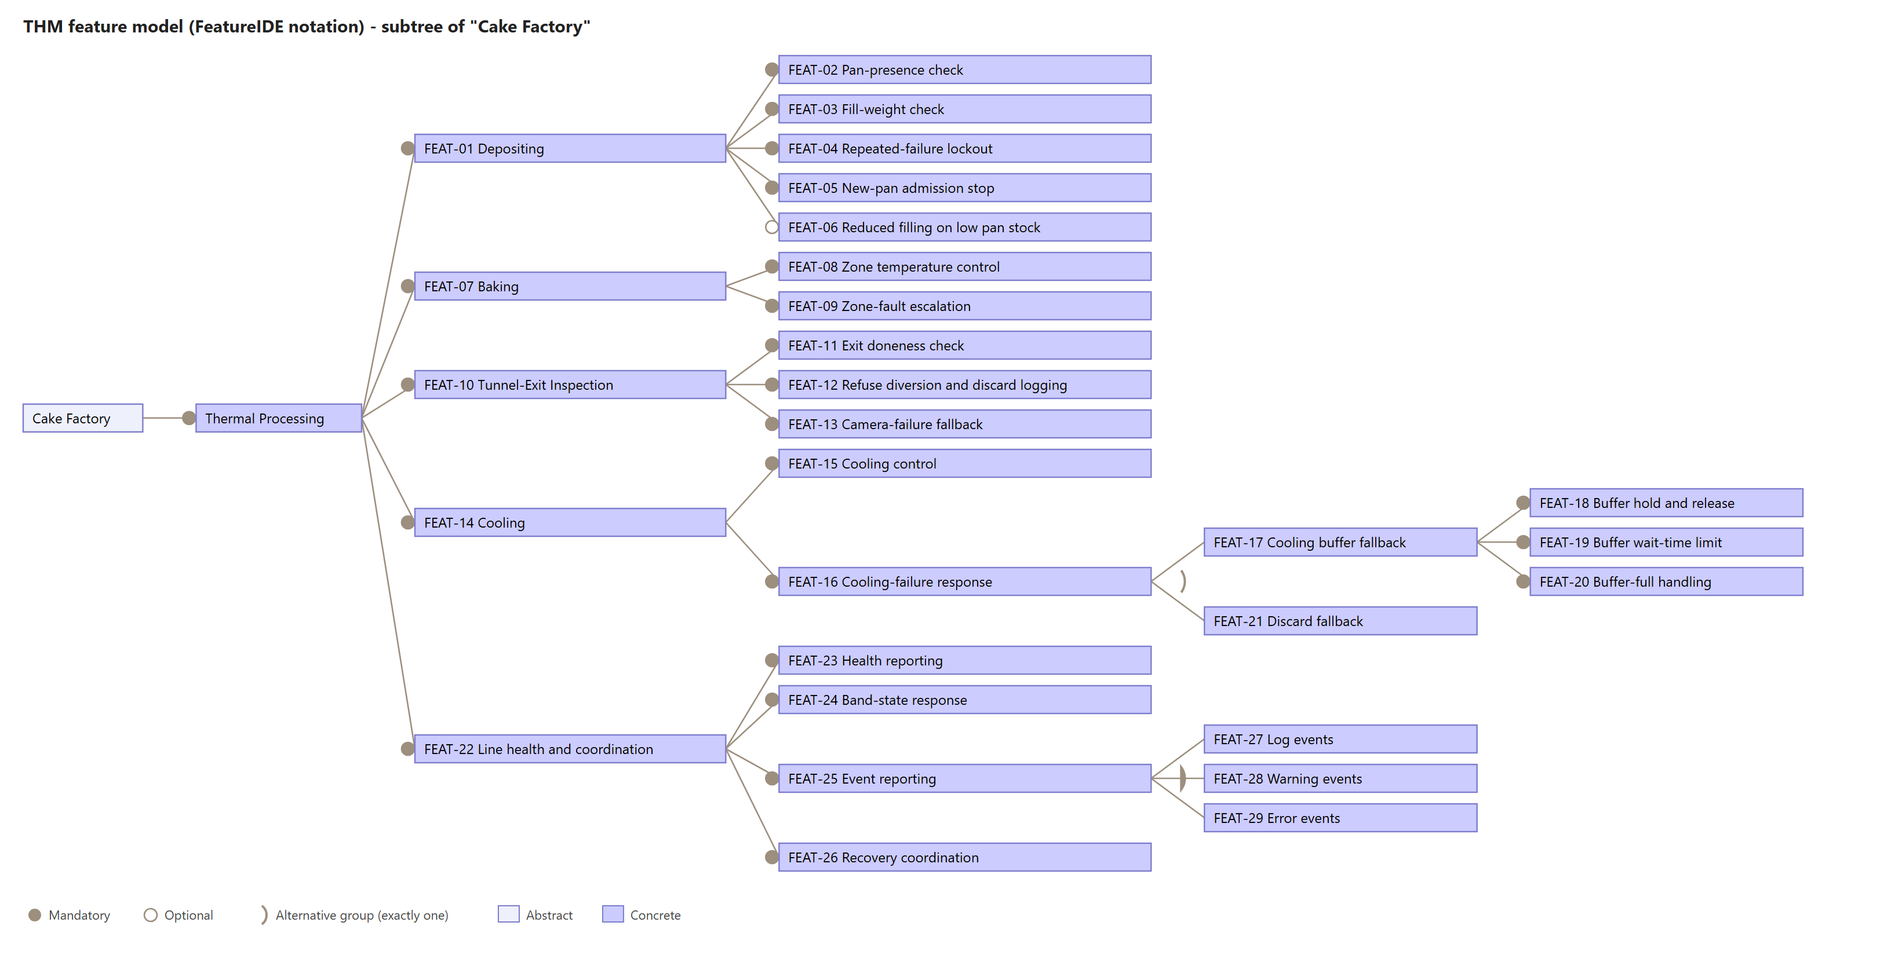
Figure: THM feature model (FeatureIDE project THM_FeatureIDE/model.xml)

Analysis Blocks

Analysis Functions
ID | Analysis function | Responsibility | Inputs | Outputs | Devices used | Features | Requirements
THM-AF-01 | Depositing Control | Check whether a pan is present and release or withhold batter; weigh every filled pan and divert out-of-tolerance pans; count wrong fills in a row and lock out; control admission of new pans (zone fault, buffer full, stop from Finishing & Packaging, band halt, lockout) and resume only when no stop reason remains; report stopped / working again to Batter Preparation; request pans and fill fewer pans on low stock. | Batter ready (batter, batch ID); Pan present; Fill weight; Clean pan supply (clean pan, stock level); Stop / resume pan admission; Zone fault; Buffer full; Band command; Resume permission | Batter release; Divert pan; Filled pan; Pan request; Pan for washing; Depositing stopped / working again; Events; Status | Pan-Presence Photoeye; Batter Depositor; Weight-Checker; Pan Diverter | 01, 02, 03, 04, 05, 06, 20, 22, 24, 27, 28 | 01, 02, 03, 04, 05, 06, 07, 08, 09, 10, 11, 12, 13, 14, 15, 16, 17, 18, 19, 20, 21, 23, 24, 25, 60, 65, 66, 67, 69, 71, 76
THM-AF-02 | Baking Zone Control | Regulate each heating zone to its setpoint in a local control loop, also while product is inside; adjust heating when out of range; flag a zone as faulty if it stays out of range; clear the flag after repair. | Filled pan; Zone temperature; Band command; Resume permission | Heating command; Zone fault; Baked cake; Events; Status | Zone Thermocouples; Zone Heaters | 05, 08, 09, 22, 24, 28 | 21, 22, 26, 27, 28, 29, 30, 31, 65, 66, 69, 71, 74
THM-AF-03 | Cooling Control | Control the cooling sprays; measure the core temperature at the cooling exit; hand cooled cakes to Finishing & Packaging; increase cooling for too-warm cakes; detect cooling failure and set the Cooling Diverter; take released buffer cakes back through cooling. | Inspected cake; Core temperature; Released cake; Band command; Resume permission | Spray control; Diverter control; Hot cake; Cooled cake; Events; Status | Cooling Sprays; Core Temperature Probe; Cooling Diverter | 15, 16, 17, 18, 19, 21, 22, 24, 28 | 40, 41, 42, 43, 44, 45, 46, 47, 49, 50, 52, 56, 61, 62, 65, 66, 69, 71
THM-AF-04 | Tunnel-Exit Controller | Check every cake leaving the baking tunnel with the Heat Camera; let only cakes at 97 °C ± 0.5 °C pass; divert all other cakes to the Refuse Container and log the reason; divert all cakes if the camera is broken or the buffer is full. | Baked cake; Cake temperature; Buffer full; Band command; Resume permission | Divert control; Inspected cake; Events; Status | Heat Camera; Tunnel-Exit Diverter; Refuse Container | 05, 11, 12, 13, 20, 22, 24 | 22, 32, 33, 34, 35, 36, 37, 38, 39, 58, 59, 65, 66, 71, 75, 77
THM-AF-05 | Cooling Buffer Management (optional) | Hold cakes in the Cooling Buffer while cooling is down; track the waiting time of every cake; release cakes in arrival order after repair; discard cakes that waited longer than T_wait; report buffer full. | Hot cake; Buffer fill state | Released cake; Buffer full; Buffer control; Events; Status | Cooling Buffer; Refuse Container | 17, 18, 19, 20, 28 | 23, 45, 48, 51, 52, 53, 54, 55, 56, 57, 58, 60, 69
THM-AF-06 | Event Reporting | Publish log, warning, error and discard events (reason, time, batch ID) of the slice. | Events from Depositing Control, Baking Zone Control, Cooling Control, Tunnel-Exit Controller, Cooling Buffer Management | Log, warning, error and discard events | none | 04, 09, 12, 13, 16, 19, 20, 21, 27, 28, 29 | 13, 18, 30, 35, 37, 38, 49, 55, 59, 62, 63, 69, 70, 77
THM-AF-07 | Health Reporting | Publish the status of every function and device of the slice at the regular interval T_hb. | Status of all functions (and through them of all devices) | Machine status (heartbeat) | none (reads all devices) | 23 | 64, 72
THM-AF-08 | Band-State Response | On band halt: stop admitting new pans, finish the product already inside. On slow-down: keep working at reduced speed. On restart: resume normal operation. | Band state change | Band command | none | 24 | 65, 66, 67, 78
THM-AF-09 | Recovery Coordination | Receive the confirmation that a machine is repaired and give the owning controller permission to resume. | Repair confirmed | Resume permission | none | 04, 09, 13, 18, 20, 26 | 19, 31, 39, 50, 60, 68, 73

External Ports
Signal | Direction | Owning analysis function | Port on block
Batter ready | In | Depositing Control | THM-AF-01
Depositing stopped / working again | Out | Depositing Control | THM-AF-01
Pan request | Out | Depositing Control | THM-AF-01
Pan for washing | Out | Depositing Control | THM-AF-01
Clean pan supply | In | Depositing Control | THM-AF-01
Stop / resume pan admission | In | Depositing Control | THM-AF-01
Cooled cake | Out | Cooling Control | THM-AF-03
Log, warning, error and discard events | Out | Event Reporting | THM-AF-06
Machine status (heartbeat) | Out | Health Reporting | THM-AF-07
Band state change | In | Band-State Response | THM-AF-08
Repair confirmed | In | Recovery Coordination | THM-AF-09

Design-level Architecture
The function blocks (THM-AF-01 to 09) run as services. The device blocks (THM-FD-01 to 13) are the physical equipment they use. The requirements say what the system does and this section says how.

Functional Devices (FD)
ID | Device | Kind | Used by | Source | Note
THM-FD-01 | Pan-Presence Photoeye | Sensor | Depositing Control | UC5 & UC6, FC8
THM-FD-02 | Batter Depositor | Actuator | Depositing Control | UC5 & UC6, FC10 | Added by us: needed to deposit the batter; FC10 mentions it
THM-FD-03 | Weight-Checker | Sensor | Depositing Control | UC5 & UC6, FC9, FC10 | UC5 & UC6 and FIN say Weight-Checker, the work package also says Checkweigher. We use Weight-Checker everywhere.
THM-FD-04 | Pan Diverter | Actuator | Depositing Control | UC5 & UC6, FC9 | Added by us: needed to divert the pan
THM-FD-05 | Zone Thermocouples | Sensor | Baking Zone Control | UC9, FC11
THM-FD-06 | Zone Heaters | Actuator | Baking Zone Control | FC11 | Added by us: needed to adjust the zone heating
THM-FD-07 | Heat Camera | Sensor | Tunnel-Exit Controller | UC9, FC12, FC13
THM-FD-08 | Tunnel-Exit Diverter | Actuator | Tunnel-Exit Controller | UC9, FC12, FC13, FC18
THM-FD-09 | Refuse Container | Buffer | Tunnel-Exit Controller, Cooling Control, Cooling Buffer Management | UC9, UC10, FC12, FC13, FC17, FC18 | one container with three input ports
THM-FD-10 | Cooling Sprays | Actuator | Cooling Control | UC10 | Table II: Cooling Control controls the sprays
THM-FD-11 | Core Temperature Probe | Sensor | Cooling Control | UC10, FC14, FC16
THM-FD-12 | Cooling Diverter | Actuator | Cooling Control | FC14, FC15, FC16 | sends cakes to the buffer or (discard variant) to the Refuse Container
THM-FD-13 | Cooling Buffer | Buffer | Cooling Buffer Management | FC14-FC18 | Optional (THM-FEAT-17)

Mechanisms realising the requirements
Req ID | Mechanism (how) | Devices
THM-REQ-02 | A photoeye at the depositing point reports pan present / absent | THM-FD-01
THM-REQ-03 | A depositor releases the recipe-defined amount of batter | THM-FD-02
THM-REQ-07 | A weight-checker weighs each filled pan; the scale calibration date is read from the device | THM-FD-03
THM-REQ-10 | A pan diverter pushes the pan off the band; the batter is emptied and the pan goes to washing | THM-FD-04
THM-REQ-26 | One PID-type local control loop per zone, running in the controller, with thermocouples as feedback and heaters as actuators | THM-FD-05, THM-FD-06
THM-REQ-28 | Heater output of the zone is changed by the control loop (setpoint offset) | THM-FD-06
THM-REQ-32 | A heat camera measures every cake at the tunnel exit (100 % check) | THM-FD-07
THM-REQ-34 | The tunnel-exit diverter pushes the cake into the Refuse Container | THM-FD-08, THM-FD-09
THM-REQ-36 | A watchdog on the heat camera; with no valid reading all cakes go to the Refuse Container | THM-FD-07, THM-FD-08, THM-FD-09
THM-REQ-40 | Cooling sprays are switched or throttled by Cooling Control | THM-FD-10
THM-REQ-41 | A core temperature probe measures the cake at the exit of the cooling zone | THM-FD-11
THM-REQ-45 | The cooling diverter sends the cake to the cooling buffer on a separate level | THM-FD-12, THM-FD-13
THM-REQ-46 | The cooling diverter is raised so that new cakes go to the buffer | THM-FD-12, THM-FD-13
THM-REQ-50 | The cooling diverter is lowered | THM-FD-12
THM-REQ-54 | The buffer keeps a timestamp per cake; expired cakes go to the Refuse Container | THM-FD-13, THM-FD-09
THM-REQ-61 | The cooling diverter is set to the Refuse Container (no buffer installed) | THM-FD-12, THM-FD-09
THM-REQ-64 | Each controller publishes a heartbeat on the message bus; the Health Monitor times out missing heartbeats | (message bus)
THM-REQ-63 | Controllers publish events on the message bus; one Event Reporting service forwards them | (message bus)

Deployment of the analysis functions
Analysis function | Deployed as | Availability class (Table II) | On crash (FC27)
THM-AF-01 Depositing Control | Docker service | 24/7; deployable with the line paused at entry only | Docker restarts the container; last saved state is loaded
THM-AF-02 Baking Zone Control | Docker service with local control loop | 24/7 critical; must not stop while product is inside | restart with last setpoints; heaters keep their last command
THM-AF-03 Cooling Control | Docker service | 24/7 critical; sprays can fail independently of band motion | restart; Cooling Diverter set by THM-REQ-46
THM-AF-04 Tunnel-Exit Controller | Docker service | 24/7; product-safety critical | restart; while down every cake is treated as "cannot be checked" (THM-REQ-36)
THM-AF-05 Cooling Buffer Management | optional Docker service (only with THM-FEAT-17) | 24/7 while the buffer holds cakes | restart; waiting times are kept in saved state
THM-AF-06 to THM-AF-09 | light Docker services on the message bus | must be available when the monitored functions fail | restart; no product is held in them

Block Definition Diagrams (BDDs)
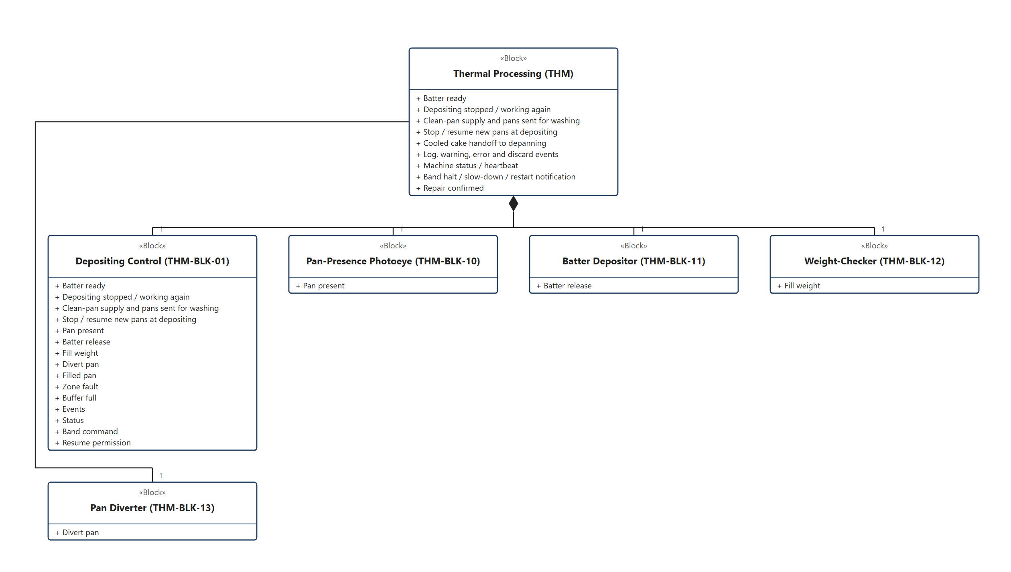
BDD: Depositing
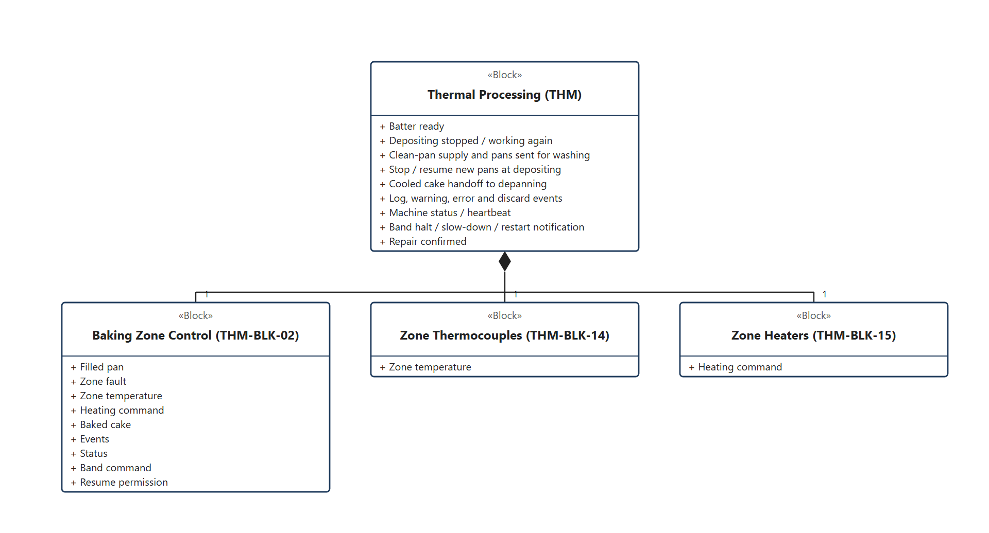
BDD: Baking
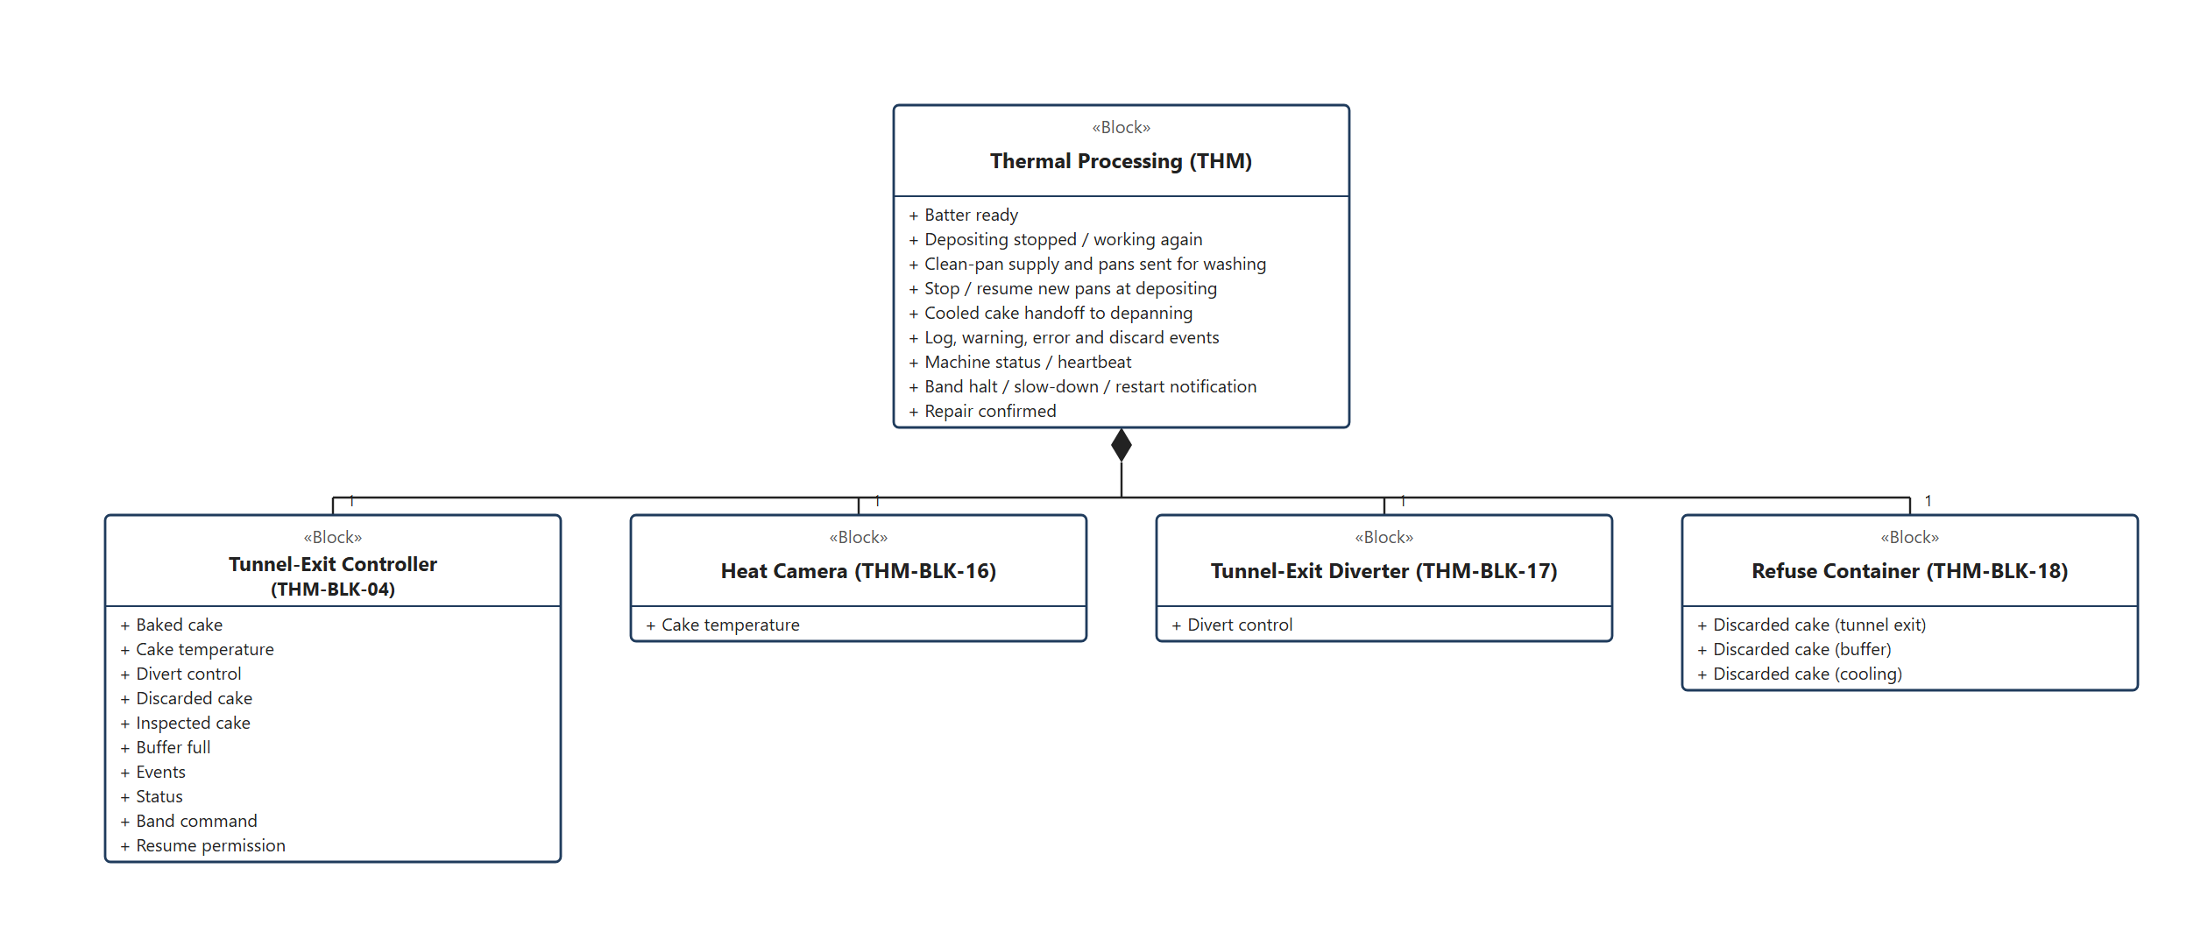
BDD: Tunnel Exit
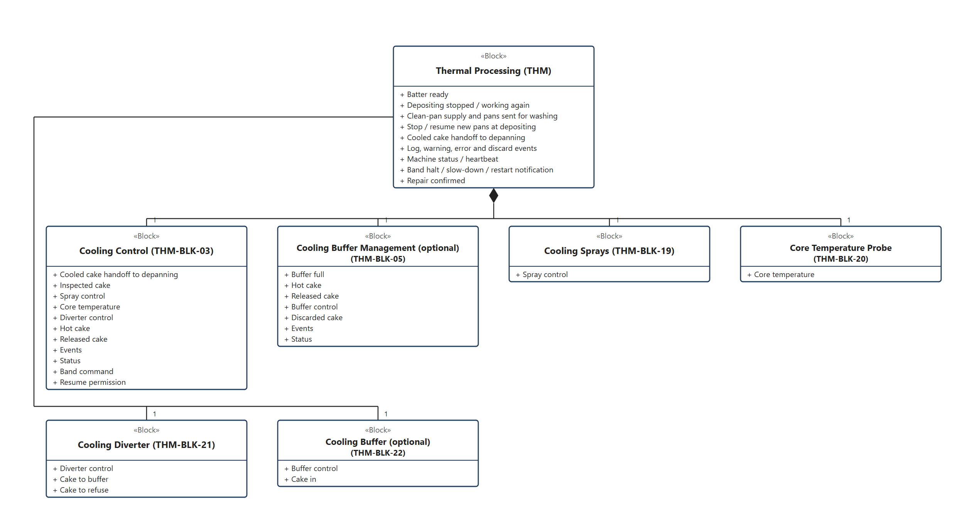
BDD: Cooling
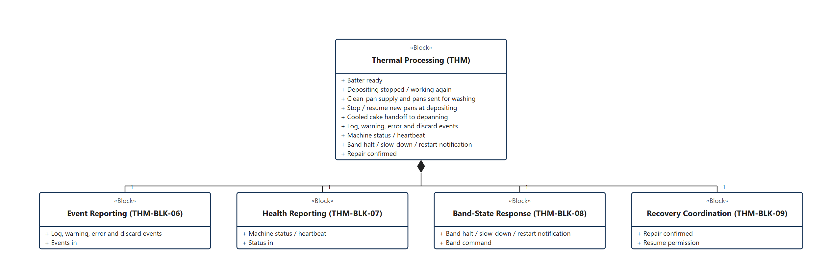
BDD: Reporting and Coordination

Internal Block Diagrams (IBDs)
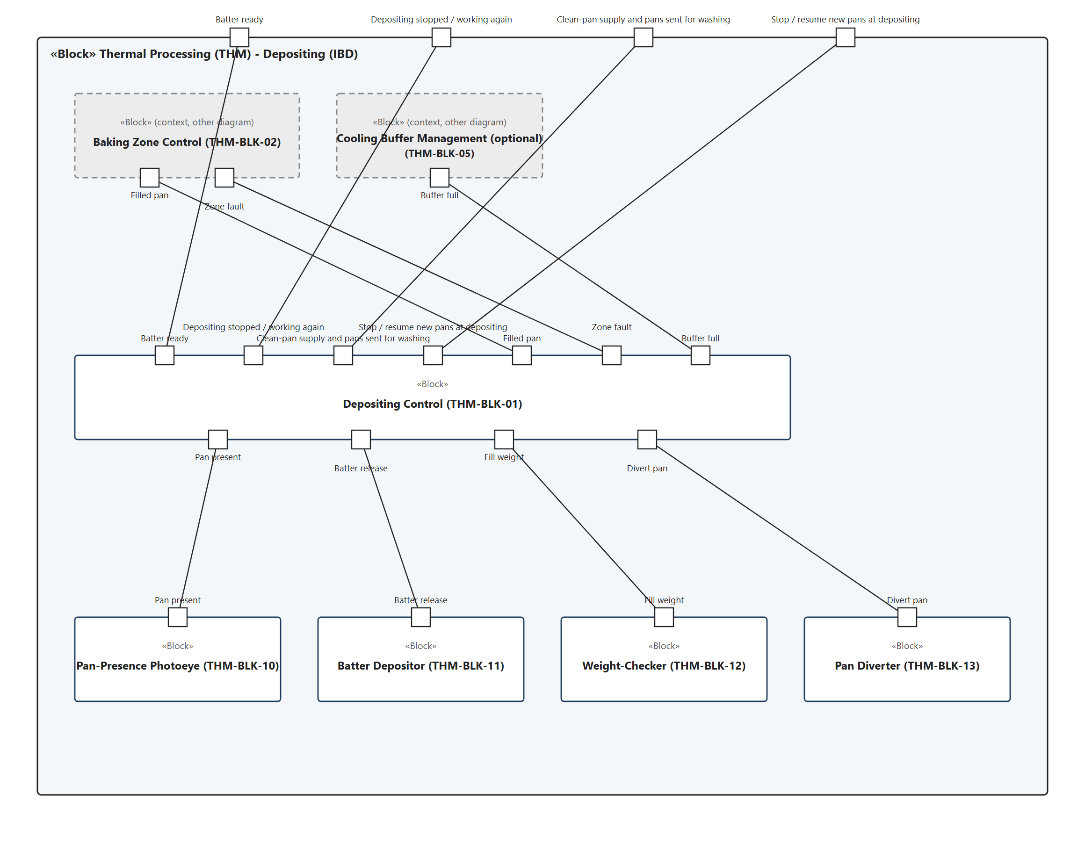
IBD: Depositing
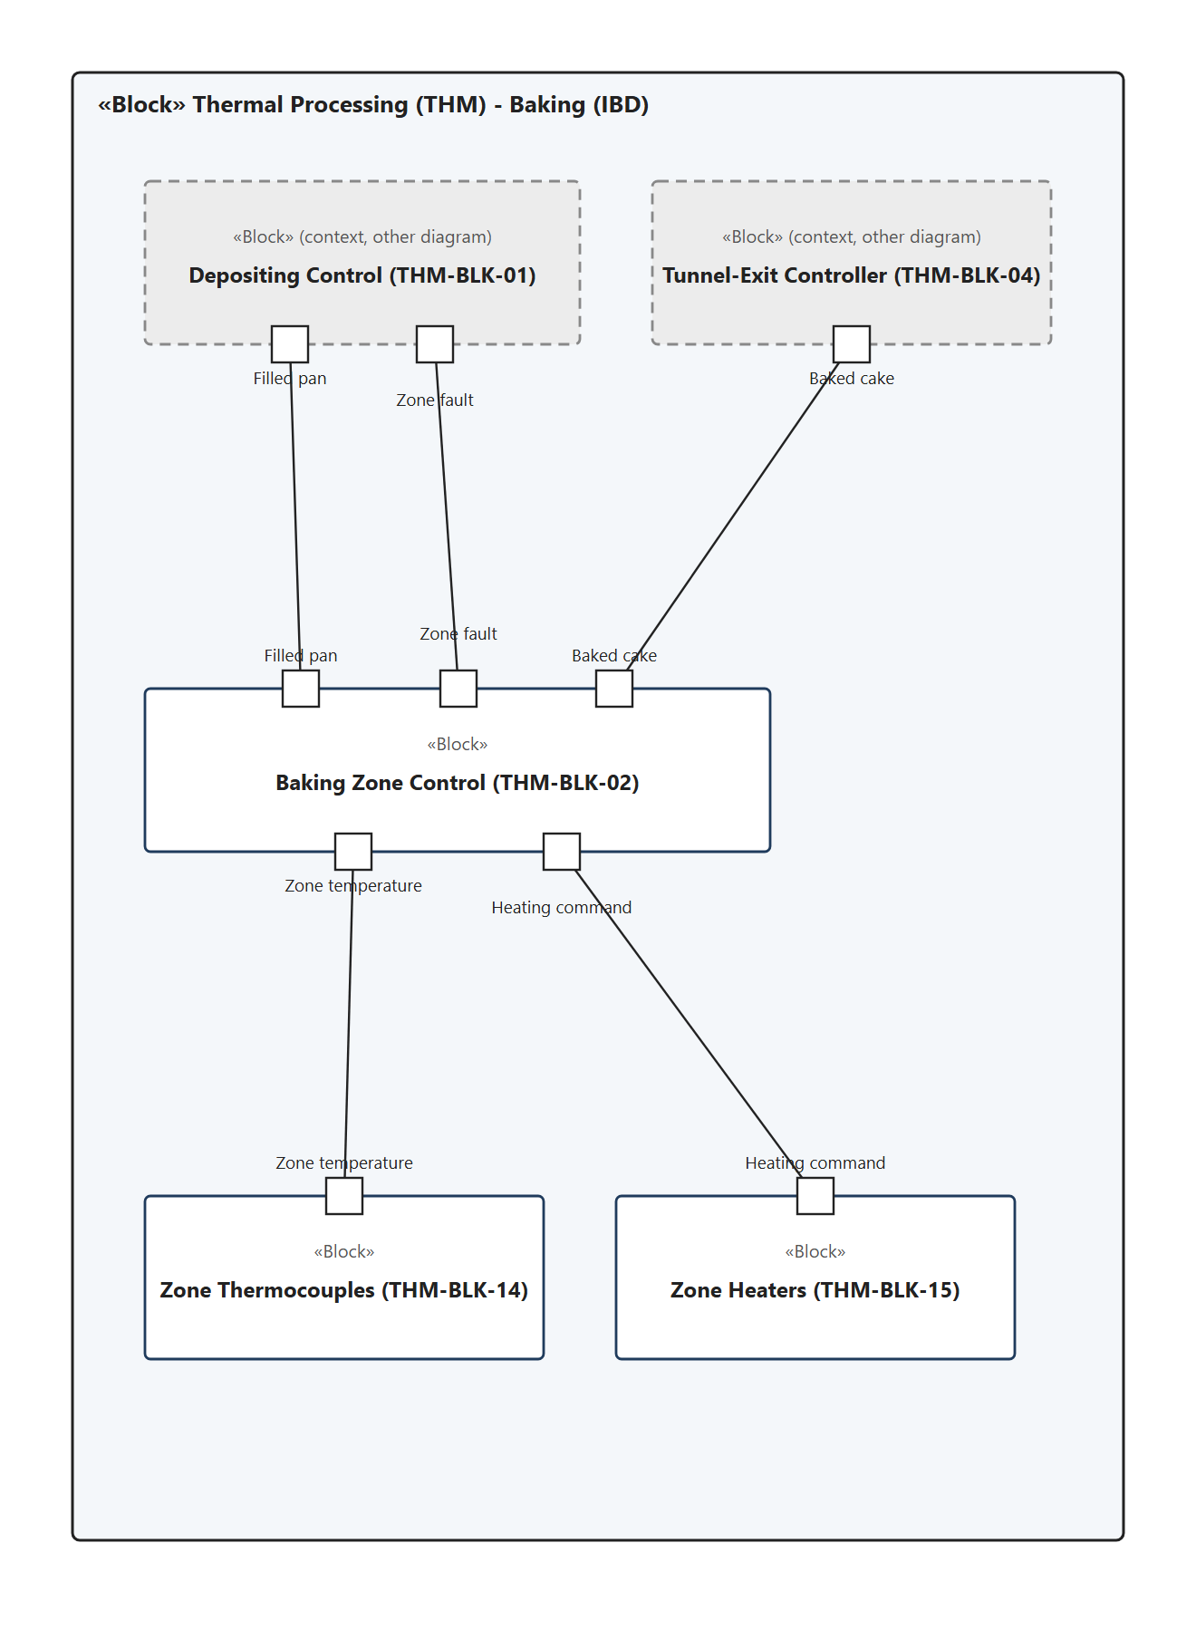
IBD: Baking
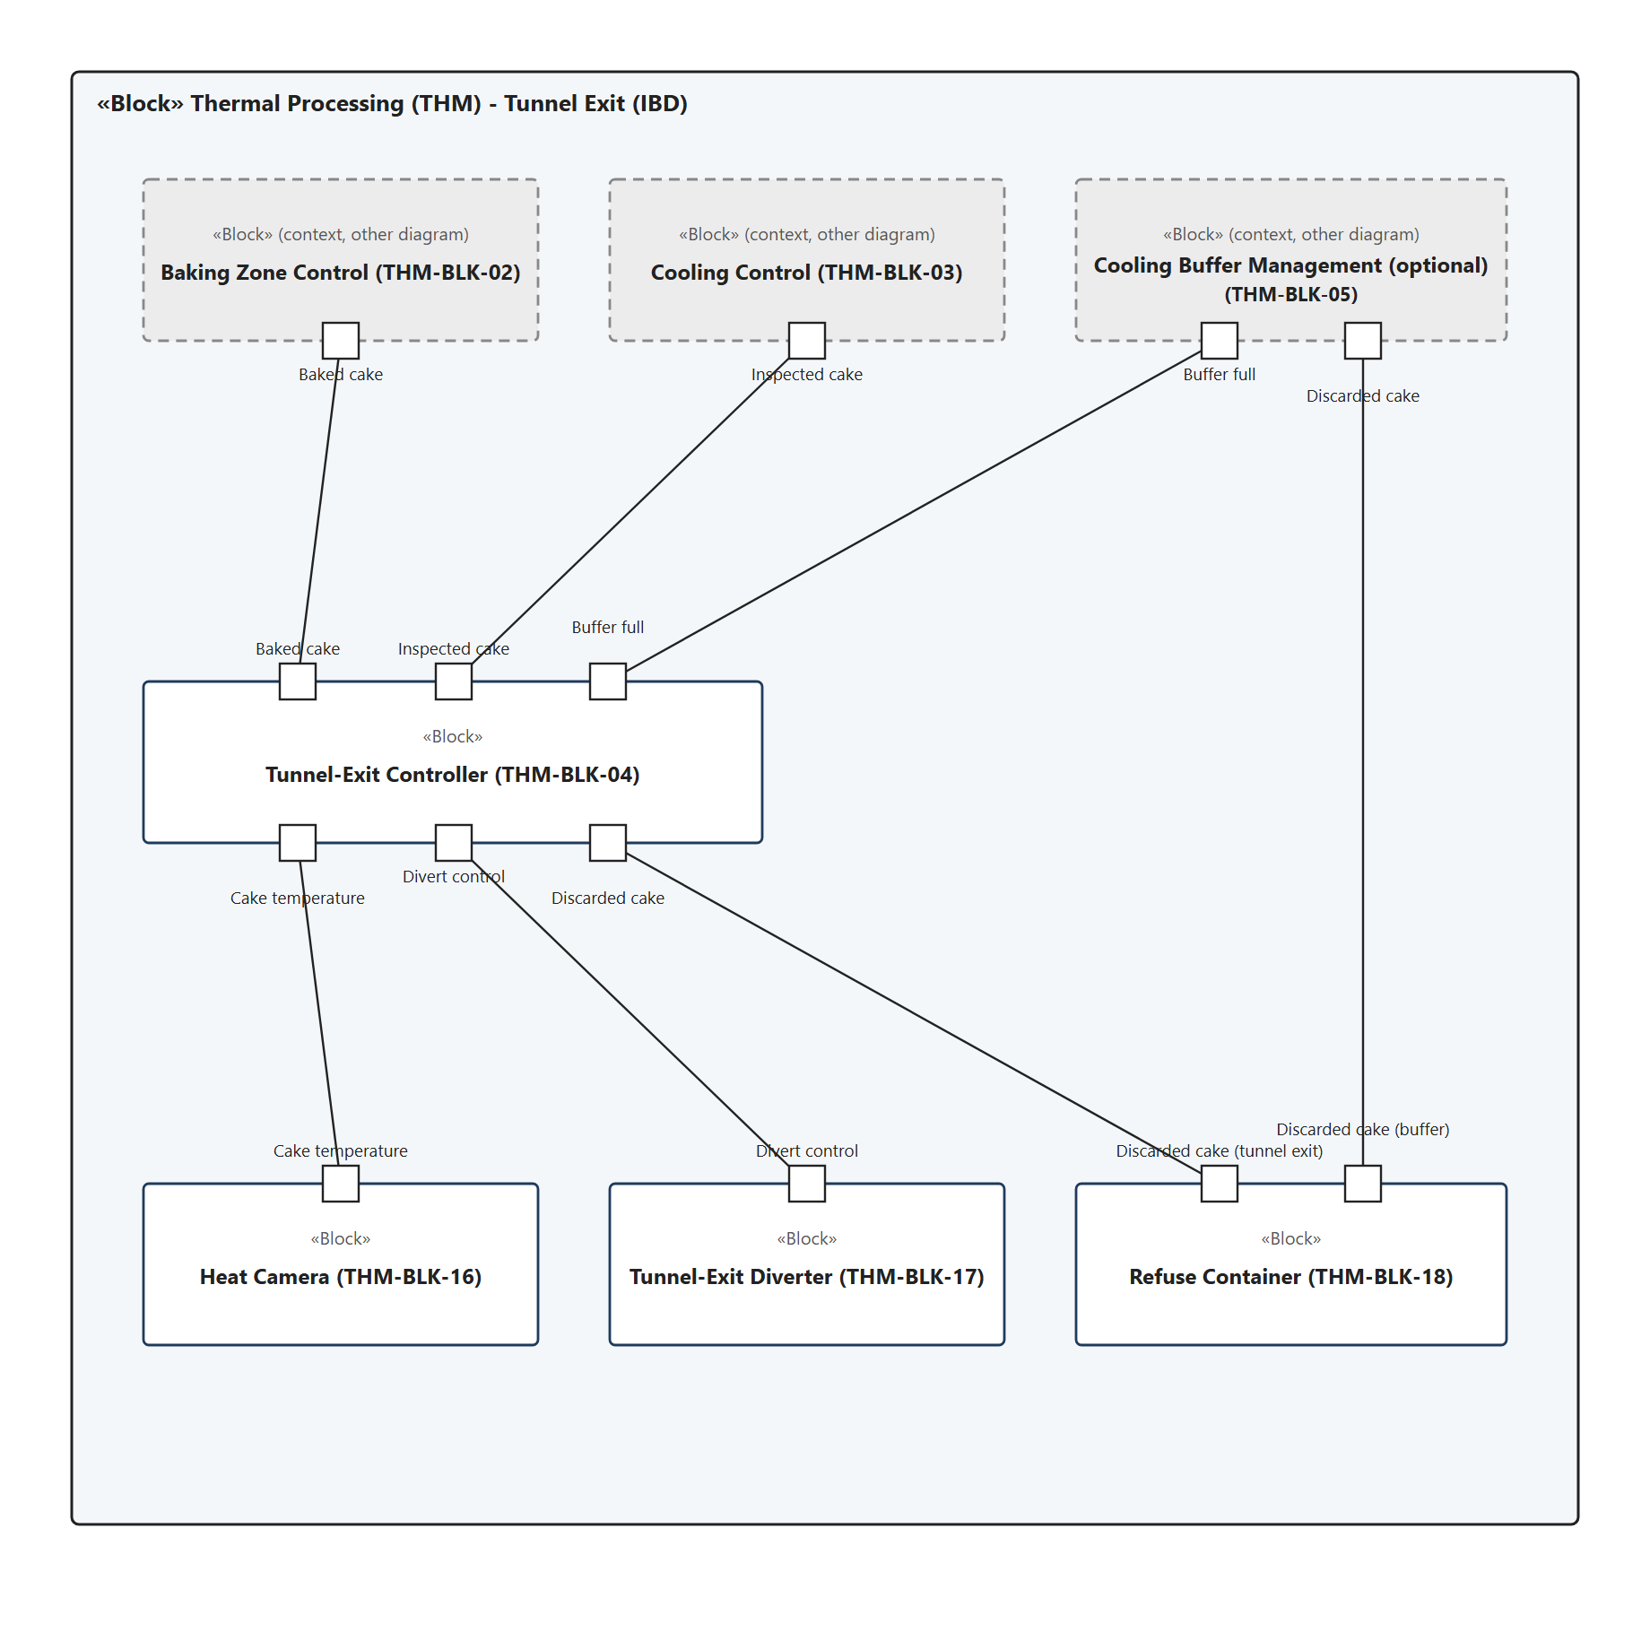
IBD: Tunnel Exit
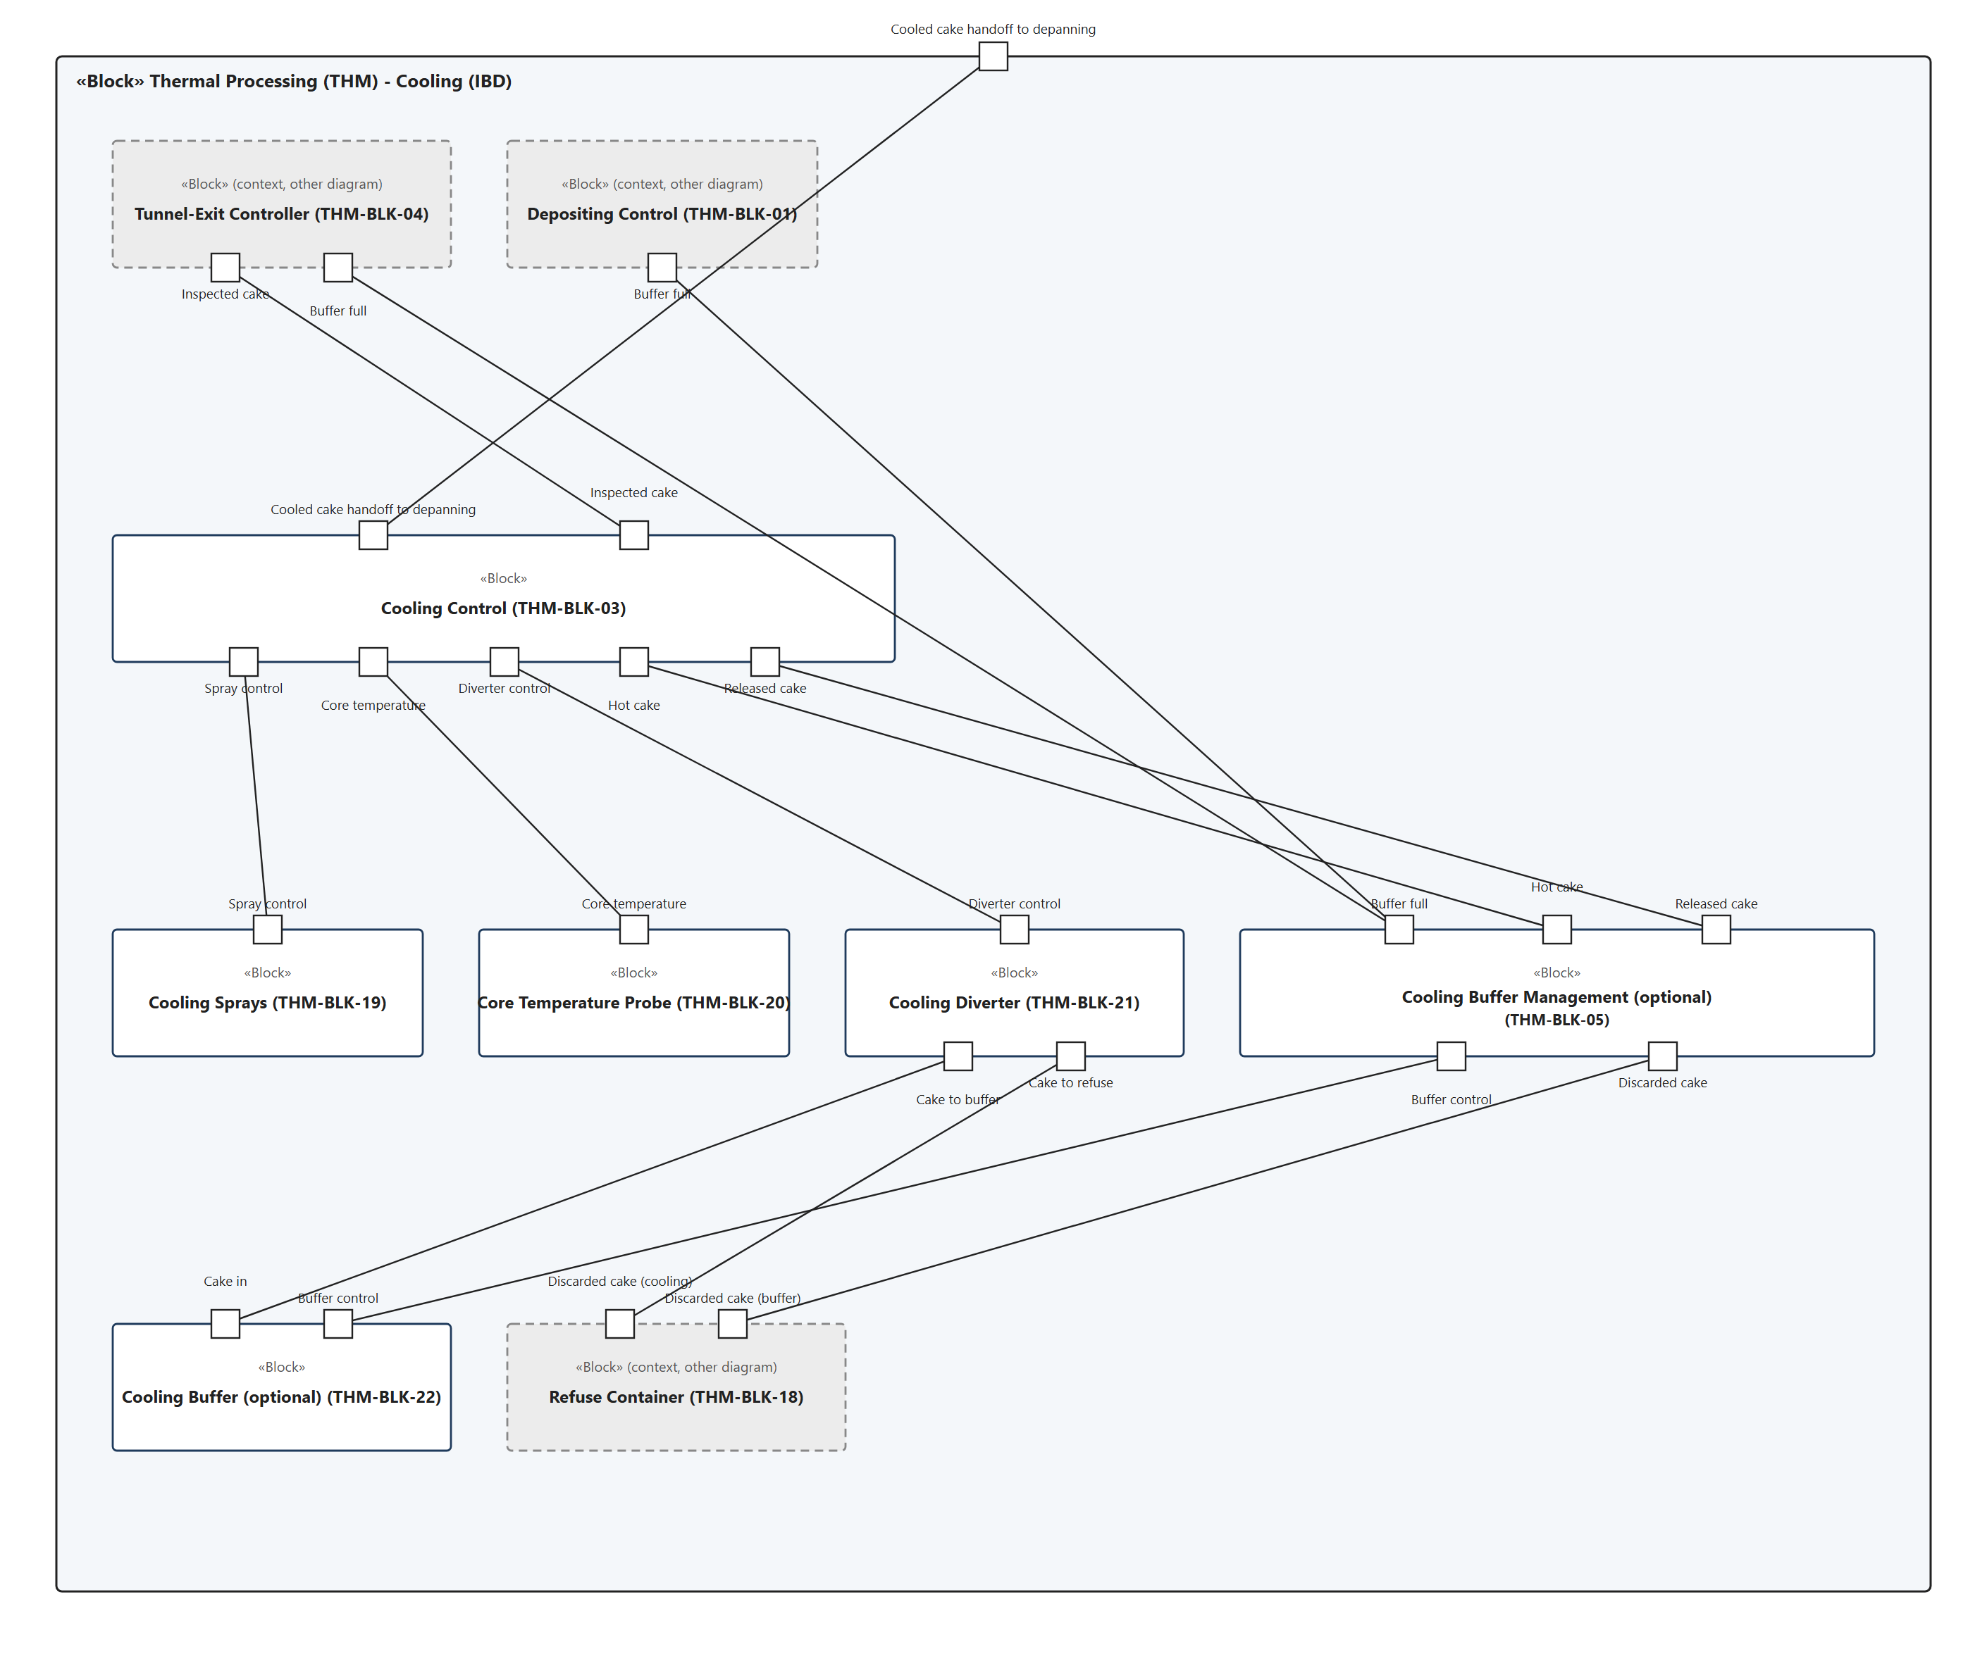
IBD: Cooling
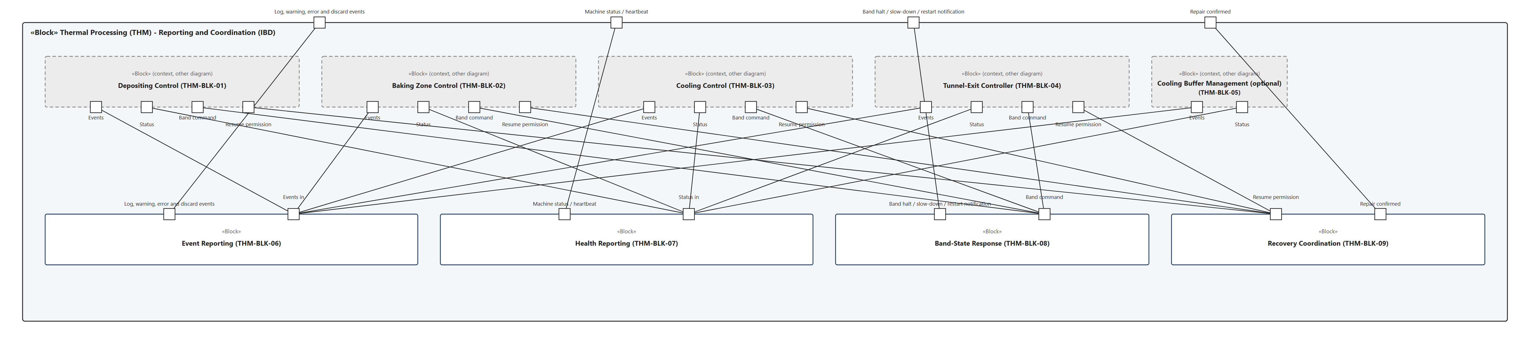
IBD: Reporting and Coordination

Traceability
Source (UC/FC) | Req ID | Rationale | Feature ID | Block ID(s)
UC5 & UC6 | THM-REQ-01 | Entry point of the slice; the batch ID is needed to trace every cake back to its batter. | THM-FEAT-01 | THM-AF-01
UC5 & UC6 | THM-REQ-02 | Batter must never be released onto an empty conveyor spot. | THM-FEAT-02 | THM-AF-01, THM-FD-01
UC5 & UC6 | THM-REQ-03 | Core function of depositing; the fill amount comes from the recipe. | THM-FEAT-01 | THM-AF-01, THM-FD-02
FC8 | THM-REQ-04 | Prevents batter from being spilled on the band. | THM-FEAT-02 | THM-AF-01, THM-FD-01, THM-FD-02
FC8 | THM-REQ-05 | Tells the pan supply that depositing is waiting; handled by the system without Maintenance. | THM-FEAT-02 | THM-AF-01
FC8 | THM-REQ-06 | Depositing recovers on its own as soon as the pan arrives. | THM-FEAT-02 | THM-AF-01, THM-FD-01
UC5 & UC6 | THM-REQ-07 | Every pan is checked (100%), not a sample. | THM-FEAT-03 | THM-AF-01, THM-FD-03
UC5 & UC6 | THM-REQ-08 | Business rule of UC5 & UC6: the weight must be within the legal standard. | THM-FEAT-03 | THM-AF-01, THM-FD-03, THM-FD-04
UC5 & UC6 | THM-REQ-09 | Special requirement of UC5 & UC6: the scale must be calibrated. | THM-FEAT-03 | THM-AF-01, THM-FD-03
UC5 & UC6, FC9 | THM-REQ-10 | Wrong fills must not be baked. | THM-FEAT-03 | THM-AF-01, THM-FD-03, THM-FD-04
FC9 | THM-REQ-11 | The pan can only be reused if it is emptied. | THM-FEAT-03 | THM-AF-01, THM-FD-04
UC5 & UC6, FC9 | THM-REQ-12 | The pan is recycled, not lost (UC5 & UC6 postcondition). | THM-FEAT-03 | THM-AF-01
UC5 & UC6, FC8, FC9 | THM-REQ-13 | UC5 & UC6 logs these events onto the message bus; needed for traceability. | THM-FEAT-27 | THM-AF-01, THM-AF-06
UC12, FC8 | THM-REQ-14 | Closes the pan loop with Finishing & Packaging. | THM-FEAT-01 | THM-AF-01
FC23 | THM-REQ-15 | FC23: if stock runs low while the washing station is down, depositing fills fewer pans. Optional because FC8 already covers a total lack of pans. | THM-FEAT-06 | THM-AF-01
FC10 | THM-REQ-16 | One bad pan is just removed; only a series points to the machine (rule on repeated failures). | THM-FEAT-04 | THM-AF-01, THM-FD-03
FC10 | THM-REQ-17 | Several wrong fills in a row mean the depositor is probably faulty. | THM-FEAT-04 | THM-AF-01
FC10 | THM-REQ-18 | FC10 is resolved by Maintenance. | THM-FEAT-04 | THM-AF-01, THM-AF-06
FC10 | THM-REQ-19 | Prevents restarting a depositor that has not been cleaned or repaired. | THM-FEAT-04 | THM-AF-01, THM-AF-09
FC7, FC10, FC11, FC18 | THM-REQ-20 | Batter Preparation must hold new batches while depositing is stopped (FC7). | THM-FEAT-05 | THM-AF-01
FC11 | THM-REQ-21 | The baking tunnel cannot go backwards, so no new pans enter a faulty tunnel. | THM-FEAT-05 | THM-AF-01, THM-AF-02
FC11 | THM-REQ-22 | Rule: pans already inside finish and are checked at the tunnel exit. | THM-FEAT-05 | THM-AF-02, THM-AF-04
FC18 | THM-REQ-23 | Internal to the slice: FC18 ends in stopping new pans (modelled in Depositing Control). | THM-FEAT-20 | THM-AF-01, THM-AF-05
FC23, FC25 | THM-REQ-24 | Washing and wrapping faults in Finishing & Packaging end in stopping new pans. | THM-FEAT-05 | THM-AF-01
FC11, FC18, FC23, FC25 | THM-REQ-25 | Several faults can overlap; resuming on the first "resume" would let pans into a still-faulty line. | THM-FEAT-05 | THM-AF-01
UC9 | THM-REQ-26 | Table II: real-time temperature control of each heating zone, incl. local control loop. | THM-FEAT-08 | THM-AF-02, THM-FD-05, THM-FD-06
UC9, FC11 | THM-REQ-27 | Table II: 24/7 critical, must not stop while product is inside; otherwise the cakes burn. | THM-FEAT-08 | THM-AF-02, THM-FD-05, THM-FD-06
FC11 | THM-REQ-28 | First reaction of FC11 before the zone is declared faulty. | THM-FEAT-08 | THM-AF-02, THM-FD-05, THM-FD-06
FC11 | THM-REQ-29 | Separates a transient deviation from a real zone fault. | THM-FEAT-09 | THM-AF-02, THM-FD-05
FC11 | THM-REQ-30 | FC11 is resolved by Maintenance. | THM-FEAT-09 | THM-AF-02, THM-AF-06
FC11 | THM-REQ-31 | Depositing resumes only on a repaired and verified zone. | THM-FEAT-09 | THM-AF-02, THM-AF-09, THM-FD-05
UC9 | THM-REQ-32 | 100% heat-camera doneness check at tunnel exit (Table II). | THM-FEAT-11 | THM-AF-04, THM-FD-07
UC9 | THM-REQ-33 | Business rule of UC9. | THM-FEAT-11 | THM-AF-04, THM-FD-07, THM-FD-08
UC9, FC12 | THM-REQ-34 | Under- and overcooked cakes must not be sold; the tunnel exit owns its diverter and refuse path. | THM-FEAT-12 | THM-AF-04, THM-FD-08, THM-FD-09
UC9, FC12 | THM-REQ-35 | FC12 logs reason, time and batch ID for traceability and recall. | THM-FEAT-12 | THM-AF-04, THM-AF-06
FC13 | THM-REQ-36 | Cakes that cannot be checked must not pass (product-safety critical). | THM-FEAT-13 | THM-AF-04, THM-FD-07, THM-FD-08, THM-FD-09
FC13 | THM-REQ-37 | Discards must be traceable. | THM-FEAT-13 | THM-AF-04, THM-AF-06
FC13 | THM-REQ-38 | FC13 is resolved by Maintenance. | THM-FEAT-13 | THM-AF-04, THM-AF-06
FC13 | THM-REQ-39 | Prevents resuming with an unrepaired camera. | THM-FEAT-13 | THM-AF-04, THM-AF-09, THM-FD-07
UC10 | THM-REQ-40 | Table II: Cooling Control controls the cooling sprays. | THM-FEAT-15 | THM-AF-03, THM-FD-10
UC10 | THM-REQ-41 | Basis for the decision between handoff and waiting zone in UC10. | THM-FEAT-15 | THM-AF-03, THM-FD-11
UC10, UC11 | THM-REQ-42 | Handoff to depanning (UC10 postcondition, UC11 precondition). | THM-FEAT-15 | THM-AF-03, THM-FD-11
UC10 | THM-REQ-43 | Business rule of UC10: cakes may only be packaged at room temperature. | THM-FEAT-15 | THM-AF-03, THM-FD-11
FC14 | THM-REQ-44 | First reaction of FC14. | THM-FEAT-15 | THM-AF-03, THM-FD-10, THM-FD-11
FC14 | THM-REQ-45 | A too-hot cake is kept in the waiting zone instead of being thrown away. | THM-FEAT-17 | THM-AF-03, THM-AF-05, THM-FD-11, THM-FD-12, THM-FD-13
FC15 | THM-REQ-46 | Rule: if cooling fails, a diverter sends the cakes to a buffer instead of throwing them away. | THM-FEAT-18 | THM-AF-03, THM-FD-12, THM-FD-13
FC15 | THM-REQ-47 | Cakes already in the zone must not be lost. | THM-FEAT-18 | THM-AF-03, THM-FD-12, THM-FD-13
FC15 | THM-REQ-48 | The buffer sits on a separate level and keeps the cakes. | THM-FEAT-18 | THM-AF-05, THM-FD-13
FC15 | THM-REQ-49 | FC15 is resolved by Maintenance; applies with and without a buffer. | THM-FEAT-16 | THM-AF-03, THM-AF-06
FC16 | THM-REQ-50 | Normal flow is restored after the repair. | THM-FEAT-18 | THM-AF-03, THM-AF-09, THM-FD-12
FC16 | THM-REQ-51 | Rule: when cooling is fixed, buffered cakes go back; oldest first. | THM-FEAT-18 | THM-AF-05, THM-FD-13
FC16 | THM-REQ-52 | A released cake can still be too warm. | THM-FEAT-18 | THM-AF-03, THM-AF-05, THM-FD-11
FC17 | THM-REQ-53 | Prerequisite for the maximum waiting time. | THM-FEAT-19 | THM-AF-05
FC17 | THM-REQ-54 | Rule: cakes that waited too long are thrown away. Default taken from the 30-minute rule of UC10. | THM-FEAT-19 | THM-AF-05, THM-FD-09, THM-FD-13
FC17 | THM-REQ-55 | FC17: log discard. | THM-FEAT-19 | THM-AF-05, THM-AF-06
UC10 | THM-REQ-56 | Alternative flow of UC10; if the repair is faster the cakes are cooled again (THM-REQ-50 to THM-REQ-52). | THM-FEAT-19 | THM-AF-03, THM-AF-05, THM-FD-09
FC18 | THM-REQ-57 | Both need to react (stop pans, divert cakes). | THM-FEAT-20 | THM-AF-05
FC18 | THM-REQ-58 | The cakes cannot be stored anywhere else. | THM-FEAT-20 | THM-AF-04, THM-AF-05, THM-FD-08, THM-FD-09
FC18 | THM-REQ-59 | Discards must be traceable. | THM-FEAT-20 | THM-AF-04, THM-AF-06
FC18 | THM-REQ-60 | FC18 is resolved by Maintenance: depositing resumes once cooling is fixed. | THM-FEAT-20 | THM-AF-01, THM-AF-05, THM-AF-09
UC10, FC15 | THM-REQ-61 | Alternative variant: without a buffer the cakes are thrown away (UC10 alternative flow). | THM-FEAT-21 | THM-AF-03, THM-FD-09, THM-FD-12
UC10, FC14 | THM-REQ-62 | Alternative variant for FC14. | THM-FEAT-21 | THM-AF-03, THM-AF-06, THM-FD-09, THM-FD-12
UC2 | THM-REQ-63 | UC2: every production station publishes log, warning and error messages onto the message bus. | THM-FEAT-27 | THM-AF-06
FC13, FC28 | THM-REQ-64 | Lets the Health Monitor detect a stopped machine (FC28, FC13). | THM-FEAT-23 | THM-AF-07
UC2, FC19, FC20 | THM-REQ-65 | Table II: Baking Zone Control must not stop while product is inside; upstream sections stop, the rest runs until empty. | THM-FEAT-24 | THM-AF-08, THM-AF-01, THM-AF-02, THM-AF-03, THM-AF-04
UC2, FC20 | THM-REQ-66 | Production proceeds at reduced speed (UC2 postcondition); the checks stay at 100%. | THM-FEAT-24 | THM-AF-08, THM-AF-01, THM-AF-02, THM-AF-03, THM-AF-04
UC2, FC19 | THM-REQ-67 | Restores normal flow without overriding a fault stop. | THM-FEAT-24 | THM-AF-08, THM-AF-01
FC10, FC11, FC13, FC15, FC16, FC18 | THM-REQ-68 | All Maintenance cases end with a repair; the signal "Repair confirmed" reports it. | THM-FEAT-26 | THM-AF-09
UC2 | THM-REQ-69 | UC2: stations publish warnings so that the Production Overseer can see them before they become errors. | THM-FEAT-28 | THM-AF-06, THM-AF-01, THM-AF-02, THM-AF-03, THM-AF-05
UC2, FC10, FC11, FC13, FC15 | THM-REQ-70 | UC2: errors may lead to halt or slow-down of the band; the Health Monitor notifies Maintenance. | THM-FEAT-29 | THM-AF-06
UC9, FC13, FC28 | THM-REQ-71 | Table II: the slice is 24/7 and critical; availability is the main quality attribute of the group. | THM-FEAT-22 | THM-AF-01, THM-AF-02, THM-AF-03, THM-AF-04
FC13, FC28 | THM-REQ-72 | Fast detection is the first step of every recovery (monitor tactic). | THM-FEAT-23 | THM-AF-07
FC10, FC11, FC13, FC15, FC18 | THM-REQ-73 | Short recovery keeps the downtime of the line low (availability). | THM-FEAT-26 | THM-AF-09
UC9, FC11 | THM-REQ-74 | Table II: Baking Zone Control must not stop while product is inside. | THM-FEAT-08 | THM-AF-02
UC9 | THM-REQ-75 | The limit 97 °C ± 0.5 °C can only be checked reliably if the measurement is clearly more accurate than the tolerance. | THM-FEAT-11 | THM-AF-04
FC11, FC18, FC23, FC25 | THM-REQ-76 | Every pan admitted after a fault is a possible waste; the baking tunnel cannot go backwards. | THM-FEAT-05 | THM-AF-01
FC12, FC13, FC17, FC18 | THM-REQ-77 | Needed for batch recall and for reporting of quality events. | THM-FEAT-12 | THM-AF-06, THM-AF-04
UC2, FC19, FC20 | THM-REQ-78 | Slow reactions would let product enter a stopped or slowed band. | THM-FEAT-24 | THM-AF-08

Coverage of the use cases and failure cases owned by this slice
UC / FC | No. of requirements | Requirements (THM-REQ-nn)
UC5 & UC6 | 9 | 01, 02, 03, 07, 08, 09, 10, 12, 13
UC9 | 9 | 26, 27, 32, 33, 34, 35, 71, 74, 75
UC10 | 7 | 40, 41, 42, 43, 56, 61, 62
FC8 | 5 | 04, 05, 06, 13, 14
FC9 | 4 | 10, 11, 12, 13
FC10 | 8 | 16, 17, 18, 19, 20, 68, 70, 73
FC11 | 14 | 20, 21, 22, 25, 27, 28, 29, 30, 31, 68, 70, 73, 74, 76
FC12 | 3 | 34, 35, 77
FC13 | 11 | 36, 37, 38, 39, 64, 68, 70, 71, 72, 73, 77
FC14 | 3 | 44, 45, 62
FC15 | 8 | 46, 47, 48, 49, 61, 68, 70, 73
FC16 | 4 | 50, 51, 52, 68
FC17 | 4 | 53, 54, 55, 77
FC18 | 11 | 20, 23, 25, 57, 58, 59, 60, 68, 73, 76, 77

Completeness checks (definition of done)
• Every UC/FC we own (14 items) is the source of at least one requirement: passed (see the table above).
• Every requirement has a rationale, a feature and at least one block: passed (78 of 78).
• Every feature that is not only a parent has at least one requirement, and every block is used by at least one requirement: passed.
• Every port of the work package (section 7) exists on one of the THM blocks: passed (9 signals).
• Only the prefix THM is used in the IDs: passed.
• Requirements say what, not how. Devices and mechanisms are in the design section (the Block column of the traceability still lists the devices involved).
• Each requirement is one sentence with "shall", a trigger or condition, a measurable value or a named parameter (see Open parameters), a source and a rationale.
• Note: we did not have the completeness definition of slide p. 56. The criteria above are the usual ones and have to be checked once against that slide.

